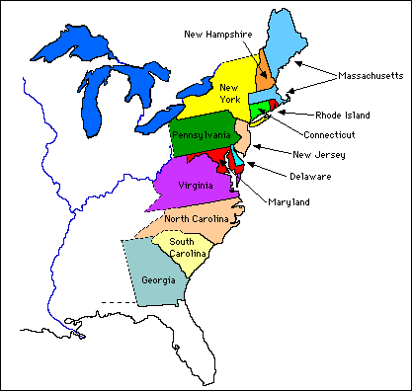
Map Questions
**Frederick Douglass was born in Maryland. He also escaped from Maryland in order to move to a free state. Be able to locate this on a map.
**Frederick Douglass escaped to New York by disguising himself as a sailor.

1. Frederick Douglass knew he did not want to be enslaved when he read about freedom in a book.
2. We remember Frederick Douglass today for his part and voice against slavery as an escaped slave.
3. An abolitionist is someone who wants to put an end to slavery.
4. Frederick Douglass believed in freedom of expression. An example of this is when he started a newspaper called The North Star.
5. Slaves did NOT have the same rights as other Americans.
6. Frederick Douglass dressed up as a sailor and got aboard a train heading north to a free state. This is how he escaped from slavery.
7. Frederick Douglass worked with Susan B. Anthony. Both wanted rights for women.
8. The Underground Railroad was a secret network of people, routes, and hiding places that helped slaves escape.
9. The war between the Confederacy and the Union ended slavery in the United States.
10. President Lincoln spoke with Frederick Douglass about the unfair treatment of African Americans.
11. Douglass moved to England (Great Britain) after he wrote his book because it was too dangerous for him in the U.S.
12. Growing up in the south made Douglass more aware of slavery. He saw how his friends and family members were treated by their owners. He was also treated poorly by his first owner. He became aware that slaves were not paid, or paid poorly, for their hard work. Douglass decided it was time to make a change.

